**EVENTS ORGANISED**

**BY**

**COMPUTER SOCIETY OF INDIA**

Bharati Vidyapeeth’s College Of Engineering, New Delhi

# **Juvenile Care Event**

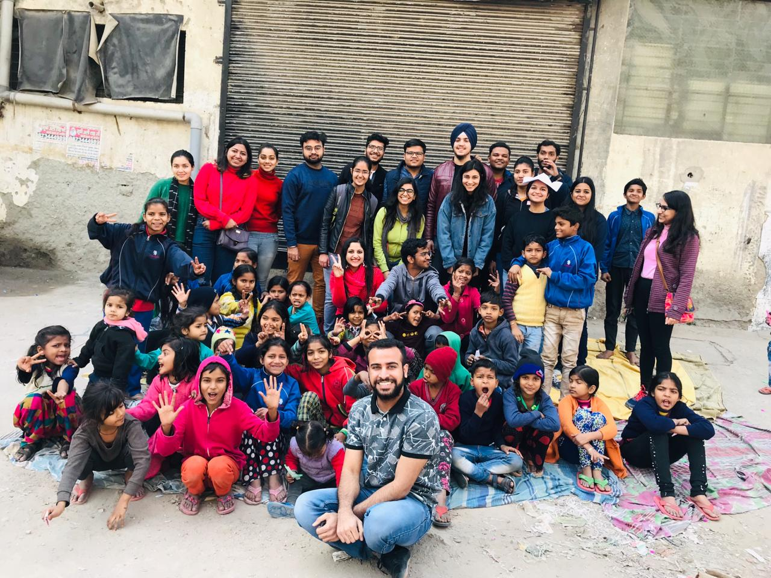

Volunteers of BVPCSI collaborated with Juvenile Care, an NGO which operates to aid underprivileged children, to interact with these children in the slums of Tagore Garden. The Society of Social Services (SSS), a sub-chapter of BVPCSI, arranged it on 26th January 2020 to celebrate Republic Day in a way which gives back to the country. The volunteers taught the children rhymes and patriotic songs and sung them with fervour, supplemented with a little origami. The day had a successful outcome.

# **Machine Learning Track**

# 

A workshop on the basics of Machine Learning was organized on 4th February during college hours. The agenda of the Workshop was to set up the python environment, introduce students to the language and it’s data types, and then introduce Machine Learning. By the end of the workshop, the students were equipped with the knowledge of the basics of Python and ML, two of the most popular fields of technology.

# **Adobe Photoshop Workshop**

BVPCSI brough to students, a Photoshop Class, to unleash their creativity on 4th February 2020. Students were walked through the basics of Adobe Photoshop, i.e. they were made familiar with the Photoshop environment, with the eventual aim to create beautiful and exciting projects. It was an interactive session and the students considered it to be highly informative.

# **Blind School Visit**

Society of Social Services (SSS), a sub-chapter of BVPCSI, organized a visit to the ‘Akhil Bhartiya Netrahin Sangh’ on 22nd February. The NGO runs a school for blind children in Tagore Garden. Around 20 members interacted with the children. They took quizzes, asked riddles, played guessing games and had fun with tongue twisters. The winners were also rewarded with small gifts.

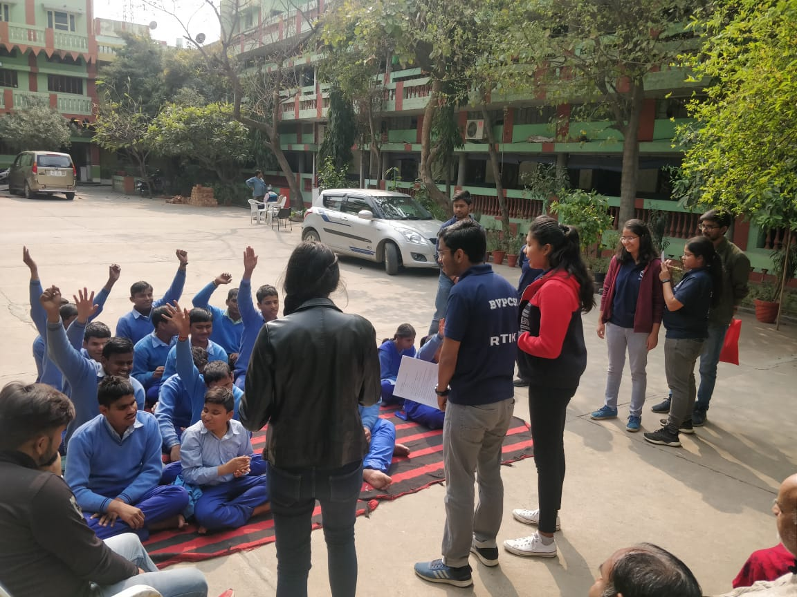

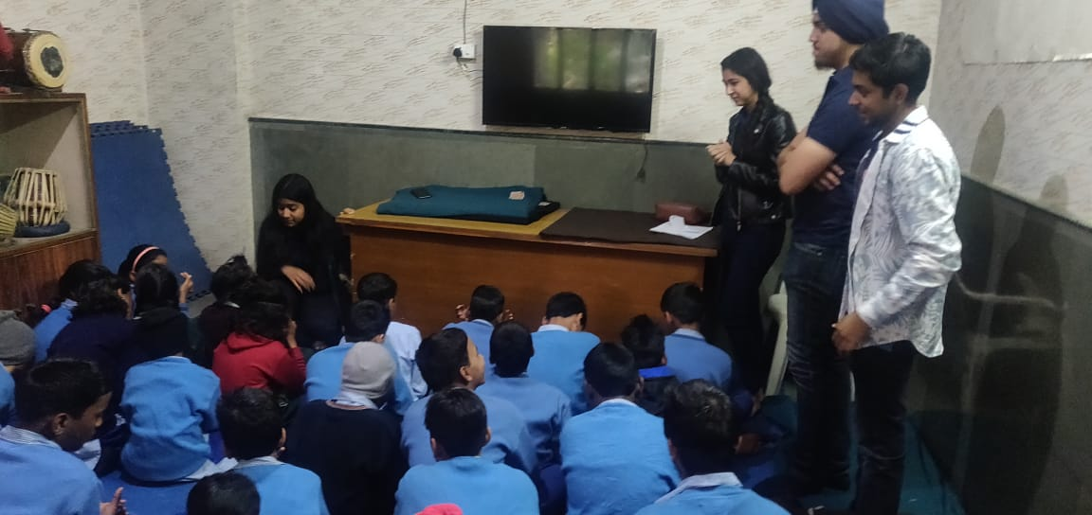

# **Code Wars: Competitive Coding**

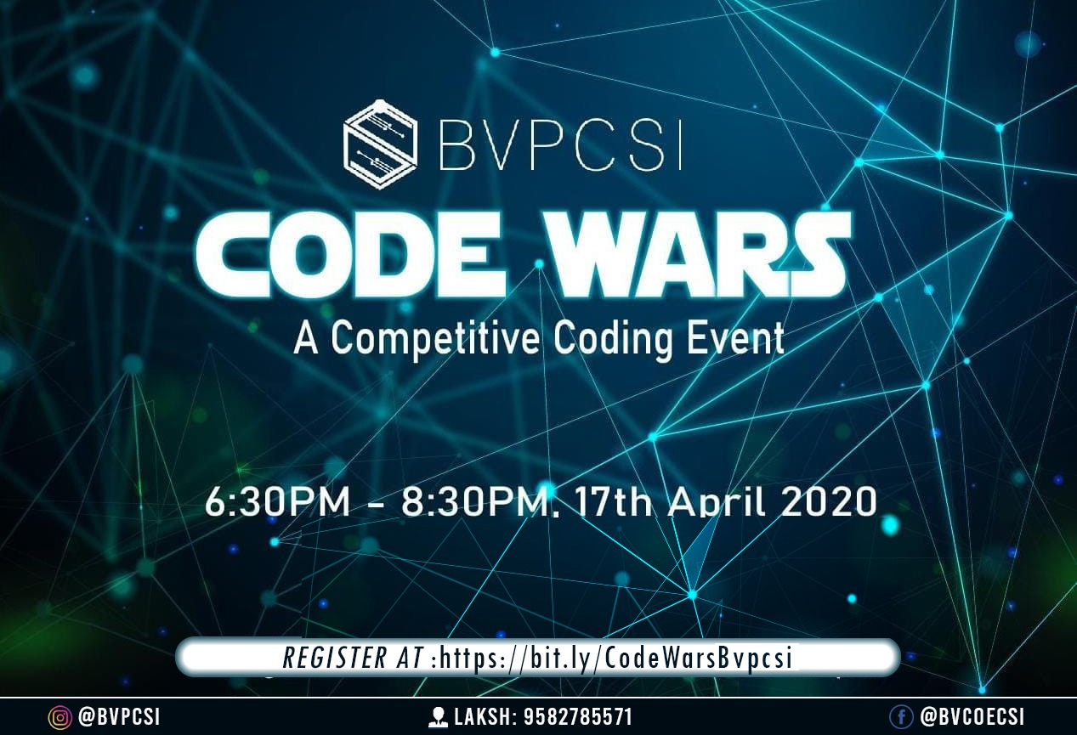

BVPCSI organized an online competitive coding event called Code Wars on 17th April 2020. The competition proceeded for 2 hours on the platform HackerRank, where it had a footfall of around 100 students from our college as well as other colleges from across the country. Coding questions were provided to test the students’ skills with answers supported in over 30 languages. Coders were ranked as per the number of problems solved and the coders with the highest score were declared winners. Winners were provided with certificates and ultimately all the participants acquired better coding skills.

# **Seminar on Self Branding**

Self-Branding is the important process of finding one’s uniqueness and building a reputation for oneself, and BVPCSI organized a seminar on this invaluable skill for the students.

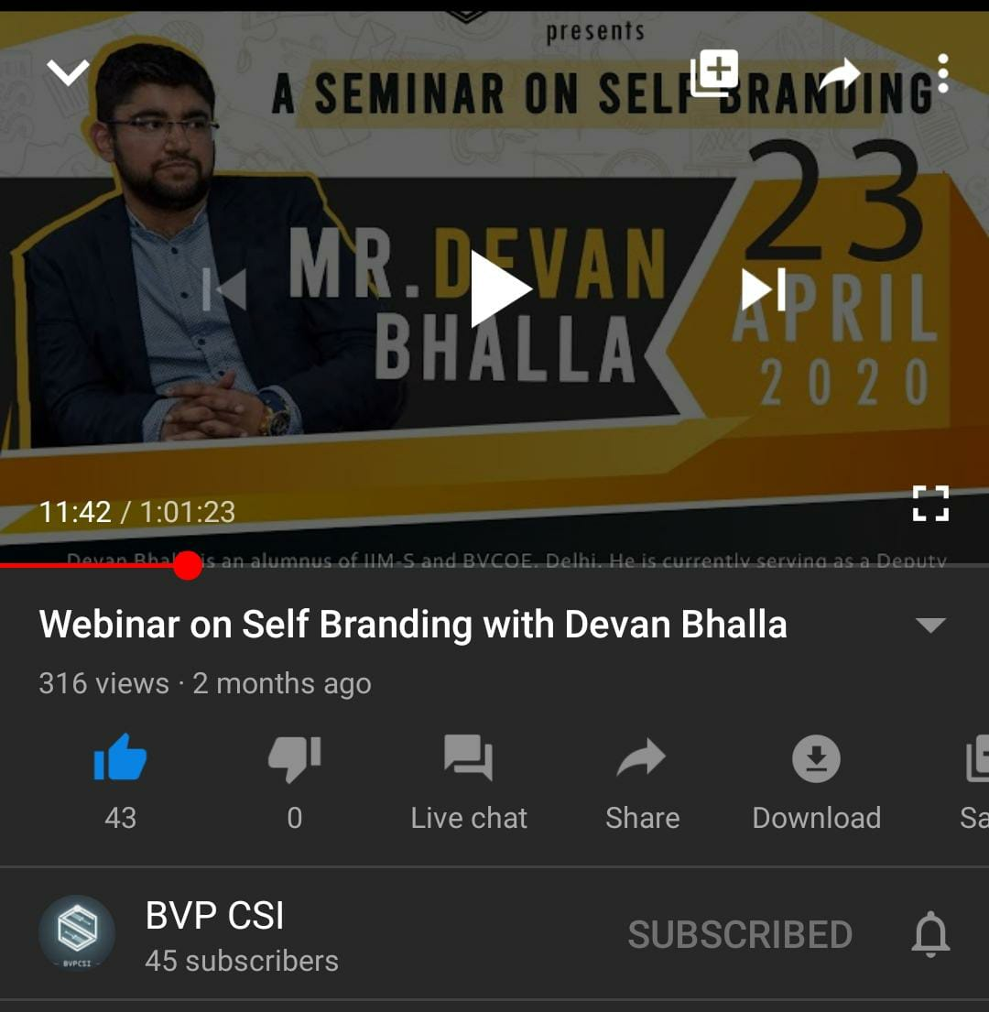

Mr Devan Bhalla spoke on the topic on 23rd April using YouTube as the platform. He is an alumnus of IIM-S and BVCOE, Delhi and is currently serving as a Deputy General Manager at Amar Ujala, one of the leading media houses of the country. The seminar was attended by more than 300 people and was a huge success.

# 

# **Satyendra Bose Innovation Challenge: The Project Showcase**

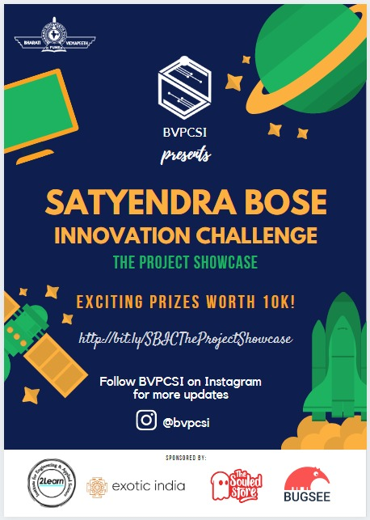

The SBIC: Project Showcase Competition was organized by BVPCSI, , and was a one of a kind innovation challenge with a footfall of over 80 students. It was a platform that catered to all levels - beginner, intermediate and advanced. Participants got hands-on experience in the presentation of their projects. The theme was open-ended. The first round was submissions Presentations and the ones who qualified to the second round had to present the entire project via online video conferencing on 14th May 2020. Apart from the top 3 winners, special prizes were awarded to the best hardware, software and beginner projects. The sponsors provided exciting prizes to all the winners and all participants got discount vouchers and e-certificates.

# **PUBG - Mobile Weekend Battle**

BVPCSI organized an action-packed PUBG -Mobile Tournament on 23rd - 24th May 2020 to dispel the Sunday Blues of the lockdown. Students could take part in a squad or could play solo to showcase their skills. Cash prizes were awarded to the winners based on different criteria. The overall experience was invigorating and dynamic.

# 

**CSI Chapter Head: Dr Dharmender Saini, Principal, BVCOE**

**CSI SBC: Mr Vishal Sharma, Asst Professor, Dept of CSE, BVCOE**

**Chairperson: Mr Varun Gupta, B.tech 8th Sem IT Dept**

**\*\*\*\*\*\*\*\*\*\*\*\*\*\*\*\*\*\*\*\*\*\*\*\*\*\*\*\*\*\*\*\*\***